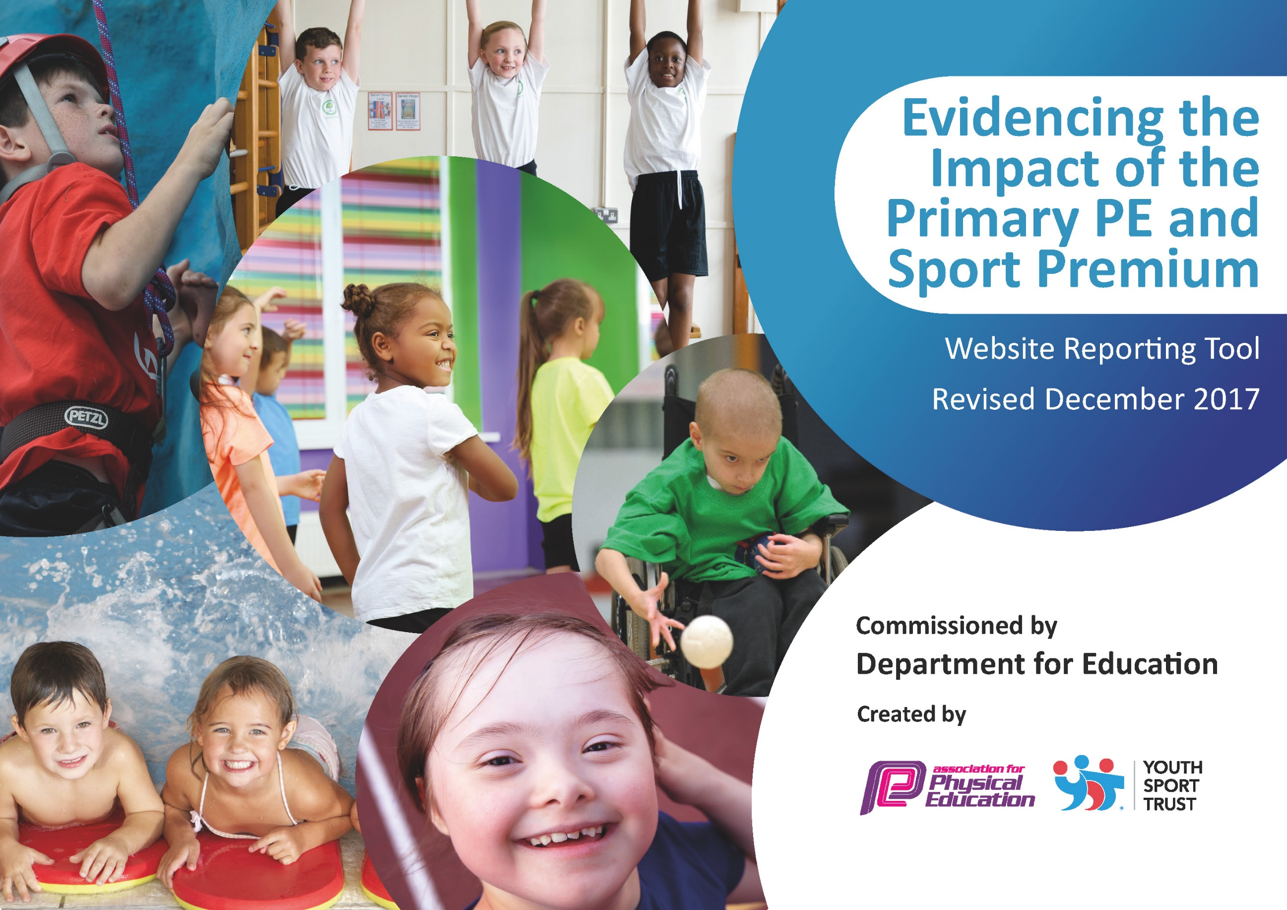

Schools must use the funding to make additional and sustainable improvements to the quality of PE and sport they offer. This means that you should use the Primary PE and Sport Premium to:

- develop or add to the PE and sport activities that your school already offers
- build capacity and capability within the school to ensure that improvements made now will benefit pupils joining the school in future years

Please visit gov.uk for the revised DfE guidance including the 5 key indicators across which schools should demonstrate an improvement. This document will help you to review your provision and to report your spend. DfE encourages schools to use this template as an effective way of meeting the reporting requirements of the Primary PE and Sport Premium.

We recommend you start by reflecting on the impact of current provision and reviewing the previous spend.
Under the Ofsted Schools Inspection Framework, inspectors will assess how effectively leaders use
the Primary PE and Sport Premium and measure its impact on outcomes for pupils, and how effectively governors hold them to account
for this.

Schools are required to publish details of how they spend this funding as well as on the impact it has on pupils’ PE
and sport participation and attainment.
We recommend regularly updating the table and
publishing it on your website as evidence
of your ongoing review into how you are using the money
to secure maximum, sustainable impact. To see an example of how to complete the table please click HERE.

Support for review and reflection - considering the 5 key indicators from DfE, what development needs are a priority for your setting and your students now and why? Use the space below to reflect on previous spend, identify current need and priorities for the future.

Key achievements to date: | Areas for further improvement and baseline evidence of need:
- Increased extra-curricular after school clubs offering a variety of sporting opportunities.  - Entered the National School Games Programme and participated in competitive and non-competitive events.  - Extended the range of sports offered as part of the statutory entitlement.  - Developed pupil confidence levels and opportunities for children to learn and engage in a competitive environment.  - Enabled pupils to access a variety of sports taught by experts and developed pathways to outside sporting agencies.  - Built self-esteem, confidence and improved the general well-being of pupils through physical activity. | - To achieve the Silver accreditation for the Sports Mark Award as part of the National School Games Programme.  - To increase the participation of pupils within school in physical activity across the school week.  - To look to make stronger links with external clubs and agencies to promote sport further.  - To increase opportunities for all pupils, including pupils with physical disabilities to participate in physical activity including sporting events.  - Develop staff competence and confidence when planning and delivering effective PE sessions supported by experts.

Meeting national curriculum requirements for swimming and water safety | Please complete all of the below*:
What percentage of your current Year 6 cohort swim competently, confidently and proficiently over a distance of at least 25 metres? | 76%
What percentage of your current Year 6 cohort use a range of strokes effectively [for example, front crawl, backstroke and breaststroke]? | 81%
What percentage of your current Year 6 cohort perform safe self-rescue in different water-based situations? | 20%
Schools can choose to use the Primary PE and Sport Premium to provide additional provision for swimming but this must be for activity over and above the national curriculum requirements. Have you used it in this way? | Yes/No
*Schools may wish to provide this information in April, just before the publication deadline.

Action Plan and Budget Tracking
Capture your intended annual spend against the 5 key indicators. Clarify the success criteria and evidence of impact that you intend to measure to evaluate for students today and for the future.

Academic Year: 2018/19 | Total fund allocated: £  Total spent to date: £ | Date Updated: October 2018
Key indicator 1: The engagement of all pupils in regular physical activity – Chief Medical Officer guidelines recommend that primary school children undertake at least 30 minutes of physical activity a day in school |  |  |  | Percentage of total allocation:
 |  |  |  | %
School focus with clarity on intended impact on pupils: | Actions to achieve: | Funding allocated: | Evidence and impact: | Sustainability and suggested next steps:
To encourage more purposeful physical activity at playtimes and lunchtimes.  To update refurbish and audit playtime equipment.  To re turf the grass side area for the football pitches to enable that the area and pitches are sufficiently playable and equipment can be used effectively.  To build self-esteem, confidence and improve general well-being through physical activity.  To implement a weekly Change 4 Life sports club targeted at the most vulnerable pupils.  To run a weekly lunchtime sports club lead by a sports coach.  Provide a range of extra-curricular  activities to increase physical activity  opportunities for pupils. | Pupils identified as being most vulnerable attend the weekly Change 4 Life Sports Club.  Play equipment is audited and replenished with a focus on sporting equipment and team games.  The grass is suitable to host and participate in football matches and tournaments.  School staff are trained in leading effective physical activity during lunch and play times.  A weekly lunchtime sports club lead by a sports coach is effective in engaging reluctant pupils in physical activity. This is targeted through Change 4 Life and the school SEAL programme.  Conduct physical activity  assessment to find out how active  our pupils are.  • Ensure pathways for higher ability  are clear.  • Ensure less active children are  given opportunities to increase  activity.  • Further improve partnerships with  external clubs.  MDS & Year 6 Sports Leaders to be  trained by Specialist PE teacher in  playground games. | £1050.00  £3000  £732.00  £1095.00 | Change 4 Life Club is in place and is well attended by targeted pupils.  A lunchtime sports club is running and is targeted to pupils who are reluctant to engage in sporting activity.  Staff training to be scheduled for Autumn term 2 and Spring 1 to develop confidence and competence.  Also in Autumn term 2 training for midday meal supervisions around leading lunch and play time activities with pupils to promote physical education.  Resources are replenished and provide pupils with a wide range of activities.  Prediction that 90% of KS2 children will choose to be physically active during playtimes and lunchtimes over a typical week, due to ever increasing lunchtime provision by end of school year.  • MDS to monitor physical activity levels during playtime.  • Activity timetables for lunchtime  • Pupil Playtime Activity Survey | To achieve accreditation for the silver sports mark/achievement supported by Hurstmere.  Continue to liaise with pupils to ascertain which extra-curricular clubs they would like to attend. Keep check  on numbers of attendees of current clubs through registers.  Ensure weekly meetings with Year 6 Sports Leader and House Captians/Parliament to equip them to facilitate well.  Continue with regular meetings with the MDS to ensure they are trained to carry out playground activities and  can highlight any additional needs for pupils in the playground.
Key indicator 2: The profile of PE and sport being raised across the school as a tool for whole school improvement |  |  |  | Percentage of total allocation:
 |  |  |  | %
School focus with clarity on intended impact on pupils: | Actions to achieve: | Funding allocated: | Evidence and impact: | Sustainability and suggested next steps:
Continue to display outstanding  work through PE Success and achievement assemblies.  Continue to create cross-curricular  links with SRE/science, to highlight the importance of PE & healthy active  lifestyles.  Introduction of a sports page in the Belmont Post. Team to report on competitions and sporting events. Sporting events to appear on the weekly newsletter too.  To appoint a school sports captain to be a positive role model of other children and raise the profile of sport within school.  To continue to develop the school’s participation in the National School Games to raise the profile of sports and encourage pupil participation.  Create a sports display to share achievements and successes with pupils.  To gain pupil feedback on their view of sports and physical activity as a way of assessing children’s progress and to further development the role of physical activity within school. | High standards and outcomes need  to be reached in lessons through  outstanding teaching. Along side  this should be accurate assessment  in order to highlight gifted &  talented children.  All children are aware of the celebrations and achievements made by others.  All children have role models to look up to and support.  Quality of teaching and learning in PE will be developed through staff CPD for all class teachers.  An assessment scheme/scheme of work will be made to support every class. Each child in the school will be assessed based on the national curriculum objectives. This is to provide future teachers/ educational settings to be able to provide the best possible teaching of sports at the relevant level. | £1,080 | High quality work is shown in books(science) that link with the PE curriculum (the body and how it works), creating an importance of PE across the school.  As a result of continued and extendedCPD/Assessment/scheme of work and utilising specialist teachers we expect to see significant impact of staff confidence, teaching and learning and pupil’s interactions.  Wide range of clubs provided by external and internal providers.  Working and liaising with more providers and sports clubs.  A raised level of physical activity for all children.  By the end of the year we predict that the large majority of teachers 100%+ will be confident in targeted areas. Personalised CPD will be put into place for individual teachers. | Arrange team teaching opportunities and supportive lesson observations in order to develop the quality of teaching, learning and assessment.  PE Teacher to continue to assess, celebrate and promote sporting successes through all mediums mentioned.

Key indicator 3: Increased confidence, knowledge and skills of all staff in teaching PE and sport |  |  |  | Percentage of total allocation:
 |  |  |  | %
School focus with clarity on intended  impact on pupils: | Actions to achieve: | Funding  allocated: | Evidence and impact: | Sustainability and suggested  next steps:
High Quality Curriculum Implemented via  a specialist PE Teacher to ensure:  • The curriculum is broad and balanced from EYSF to KS2.  Children can access all areas of the PE curriculum in every KS.  Children all access 2 hours of quality  PE with a specialist teacher and class teacher each week.  To continue to develop team teaching.  To continue to develop training for all staff.  To continue to develop staff pedagogy.  All Year groups to follow the gymnastics scheme of work. | CPD is continuous with class  teachers and TAs fully taking part in PE lessons with the specialist teacher at least once a week. Staff  to highlight any weaknesses and  be a point of action.  Updated PE curriculum to assist  staff with delivery of PE  curriculum where necessary.  Quality and quantity of resource  for lessons purchased to allow for  outstanding physical education  and pupil attainment.  Training for PE Co-coordinators which is supported by sports coach.  Borough CPD training/courses attended.  Staff survey completed.  Pupil voice completed.  Enhanced and enriched schemes of work and curriculum offered inclusively to all pupils.  All indoor PE to be taught by class teachers-linking progression of skills. | £5000. | PE survey completed by staff and used as a professional tool.  An increased level of good or better teaching of PE.  All teachers can follow a gymnastics scheme of work which targets the skills required by all children. An increased level of good or better teaching of PE.  All lessons will show clear progression of skills. | Further professional learning opportunities for all staff. Including peer teaching/coaching.  Monitor and implement more training needs required by staff.  Monitoring of teaching and learning to ensure consistency of skills and progression.  Continue to use staff surveys to highlight key areas needed for CPD.  Further development of PE  Curriculum used.  Continued working with PE  teacher and staff in combination  to improve knowledge and  confidence of all staff.
Key indicator 4: Broader experience of a range of sports and activities offered to all pupils |  |  |  | Percentage of total allocation:
 |  |  |  | %
School focus with clarity on intended  impact on pupils: | Actions to achieve: | Funding  allocated: | Evidence and impact: | Sustainability and suggested  next steps:
To offer Year 6 children the opportunity to attend school journey and take part in many outdoor activities and sports related tasks.  To offer more pupils the opportunity to engage in competitive sports against other schools.  To experience a broad range of sports and to develop competence to excel in physical activities.  To enable pupils to access a variety of sports taught by experts in their field. Pathways made available for outside school participation. | Children gain the experience of being on a residential.  - To face new challenges.  - To experience success and feel positive.  - To be aware of risks and make decisions.  - To communicate effectively and work as a team.  - To help each team member give their best.  - To face challenge and develop confidence.  - To become independent.  - To be aware of the wider world.  - To explore and learn about new contrasting environments.  Children are taught and supported by specialist coaches. They will support the development of teams in specific sports and events linked to the school games. Coaches join teachers at the events to assist in coaching the team/s.  Coaches employed to run afterschool clubs. Coaches offer the opportunity to promote their club/ sports at the clubs and in assemblies.  Participation in school games.  Links with other schools to arrange competitive games.  Inter games between classes and year groups. | £2100  £1,278.00  £1,460 | Children will participate in a wide variety of outdoor and sporting activities; learning and developing new skills.  School games participation and results.  Registration to events.  Pupil voice.  As a result, pupils enjoy the specialist teaching and participation in school games. The pupils make good or better progress.  Before and after pupil voice questionnaires.  Display of achievement in the school hall. | Sharing good practice across the schools game partnership.
Key indicator 5: Increased participation in competitive sport |  |  |  | Percentage of total allocation:
 |  |  |  | %
School focus with clarity on intended  impact on pupils: | Actions to achieve: | Funding  allocated: | Evidence and impact: | Sustainability and suggested  next steps:
To offer more pupils the opportunity to engage in competitive sports against other schools.  To raise confidence levels and opportunities for children to learn and engage in a competitive environment.  To organise and run a sports day for the whole school, to encourage and experience competition within school.  Pupils to feel they have the opportunity to take in a range of athletic events. To encourage parents and the wider community to be involved with physical activities and games.  Continue to offer a wide range of  activities both within and outside of  the curriculum in order to give the  best possible opportunities for all of  our pupils.  • Focus on particularly those pupils  who do not take up additional PE and  Sport opportunities, and those  highlighted through Pupil Premium. | Children are taught and supported by specialist coaches. They will support the development of teams in specific sports and events linked to the school games.  Coaches join teachers at the events to assist in coaching the team/s.  Sports coaches to be provided on the day of sports day to help with the running of the event.  They will also meet with the PE co-ordinators to discuss ideas and form a sports day that all children will be able to participate in and enjoy.  Continued work between  specialist PE teacher from All Stars  to consistently review the  curriculum to ensure it is meeting  high expectations, and offers  varied experiences, readying our  pupils to further develop in their  secondary education.  • Use pupil feedback and surveys to review the curriculum, ensuring it both progressive, and inspires and engages them.  • Enter competitions arranged  through school games and other sporting bodies.  • Involve external  coaches/companies where  possible to engage pupils in  alternative activities. | ££ | School Games results  Registration to events  Pupil voice  Pictures  Sports day meeting minutes  Questionnaires  Pupil Voice  Teacher feedback  Advance to the silver mark award for third year running; showing  that we are committed to our  extra-curricular competitions across key stages and activity types.  Through lessons, KS2 children are  exposed to high quality PE lessons that prepare them for secondary education. | To use new initiatives and improve the 30minutes daily exercise in school for all children.

